Republic of North Macedonia
Ministry of Transport and Communications

Western Balkans Trade and Transport Facilitation Project

CLARIFICATION NO. 1

To the Request for Bids for the procurement of

Provision of customs related equipment - CCTV and ANPR systems –

installation, commissioning and training of Custom Administration staff

Ref. No.: WBTTFP-8929-MK-121E-RFB
Issued on date: April 27, 2023

To all prospective Suppliers and to all firms that have obtained the RFB documents

Dear All,

With reference to the question raised by the prospective Supplier and pursuant to the issued RFQ for the stated subject, please find enclosed the Clarification Table below with the questions and answers.

 | CLARIFICATION TABLE
No. of Question | Question | Ref. to the BD (RFB) | No. of Answer | Answer | Category:  Clarification or Amendment
1 | Detailed Technical Specifications, Position 20 – Monitor  Q: Considering that is required a video surveillance system with cameras with resolutions above 4 MP, we believe that the requirement of two VGA inputs is misspecified. Namely, resolutions above 4 mega pixels can be reproduced exclusively on devices with HDMI, DP and/or DVI ports.  Is it acceptable to offer a monitor that has a minimum of 2 HDMI and a minimum of 1 VGA and a minimum of 1 DVI port that will fully satisfy the quality of image reproduction produced by the cameras? | Section VII – Schedule of Requirements -  Detailed Technical Specifications - Required and Offered -  Position no. 20 | 1 | A: Requirement in Position no. 20 is changed from at least 2 to at least 1 VGA Interface.  Please see Amendment no. 3. | Amendment
2 | Detailed Technical Specifications, Position 21 - Keyboard  Q: Considering that is required a video surveillance system with PTZ cameras with resolutions above 4 MP, we think that the VGA interface requirement is misspecified. Namely, resolutions above 4 mega pixels can be reproduced exclusively on devices with HDMI, DP and/or DVI ports.  Is it acceptable to offer a keyboard that has a minimum of 1 HDMI and a minimum of 1 DVI port, which will fully satisfy the quality of image reproduction produced by the cameras that will be controlled by the keyboard? | Section VII – Schedule of Requirements -  Detailed Technical Specifications - Required and Offered -  Position no. 21 | 2 | A: All requirements in the technical specification for this Position 21 are mandatory and remain unchanged.  The conection with equipment with older technology (VGA) that Customs use should be provided. | Clarification
3 | Detailed Technical Specifications, Position 23 - Network Switch  Q: For position 23 is not specified that it is an industrial switch, such as position 22. We believe that has been made a technical error in the requested temperature range for the switch from position 23. The temperature range specified in this way applies exclusively to industrial switches, such as which is defined in clause 22. Is it acceptable to offer a network switch with a temperature range of a minimum of -10 Degrees to 50 degrees Celsius? | Section VII – Schedule of Requirements -  Detailed Technical Specifications - Required and Offered -  Position no. 2 | 3 | A: Working temperature range from -10 °C to +50 °C is accepted and requirement in Position no. 23 is changed.  Please see Amendment no. 3. | Amendment
4 | Detailed Technical Specifications, Position 29 - Fiber optic cable  Q: In this position is specified self-supporting flat fiber optic cable. Considering that the flat performance of the cable is required, we consider this to be a mistake because it is not intended for outdoor aerial installation. Can it be offered self-supporting regular (non flat) fiber optic cable according to IEC 60794-3-10 standard instead of the requested type G.657A1? | Section VII – Schedule of Requirements -  Detailed Technical Specifications - Required and Offered -  Position no. 29 | 4 | A: The technical characteristics of the type G.657A1 optical cable are mandatory. Self-supporting flat Fiber optic cable with better/higher characteristics can be proposed. | Clarification
5 | Detailed Technical Specifications, Position 39 - Metal pole  Q: In this position is specified metal pole with strictly defined features and colour. Considering that the production of a metal pole with those features will be done specifically for the project and the companies do not have it in serial production, it's problematic to provide a brochure on which the strictly required technical details will be specified. Is it necessary to submit a brochure for this position? | Section VII – Schedule of Requirements -  Detailed Technical Specifications - Required and Offered -  Position no. 39 | 5 | A: The submission of a brochure/data sheet with the specified technical characteristics of the metal pole is mandatory. | Clarification
6 | Q: Please clarify whether the equipment is exempt from import duties and VAT? | RFB | 6 | A: The WBTTF Project is not exempt from import duties and VAT, thus supply and installation of equipment as well as required services are not exempt from import duties and VAT. | Clarification
7 | Q: Considering that this is an ANPR project, should the required reference in Qualification Criteria refer to experience of delivery and performance of an ANPR system which is similar in nature and complexity? | Section III - Evaluation and Qualification Criteria -  3.1 Qualification Criteria (ITB 37.1) –  (b) Specific Experience | 7 | A: Please note that this project is for provision of CCTV and ANPR systems, Data storage system, and System central management, it is not only ANPR project. In the Qualification Criteria is clearly stated what is similarity in nature and complexity. Please note that similar projects are: CCTV, Data storage system and System central management; or: ANPR, Data storage system and System central management; or: CCTV, ANPR, Data storage system and System central management. | Clarification
8 | Question referring to Item 17 - Application Server, part for “System Management”, clause  Point a - Access to the system application should be WEB based  Q: Please clarify if this requirement is mandatory, or we can propose application based on client – server communication? | Section VII – Schedule of Requirements -  Detailed Technical Specifications - Required and Offered -  Position no. 17 | 8 | A: The requirement for WEB access to the system application is mandatory due to the advantages of this solution for the beneficiary in the process of exploitation and maintenance of the system. Access to the system application need to be WEB-based and this requirement remain unchanged. | Clarification
9 | Question referring to Item 5 - IP Panoramic camera type 2  Q: According the Table: Place of delivery (PoD) – Final Destination (Project Sites) on page 75, this cameras should be on CO Tabanovce and CO Bogorodica. However, on the drawings there is no symbol for this camera. Please clarify which document is correct drawings or the BoQ? | Section VII – Schedule of Requirements -  Detailed Technical Specifications - Required and Offered -  Position no. 5 | 9 | A: The cameras are shown in the drawings, but with the same marking and color as the cameras from item 4. The corrected drawings for the mentioned locations are attached on the end of this Clarification document. | Clarification
10 | Question referring to IP Panoramic camera type 2, part for “System Management” clause  Point b - Lens size from 2mm to 4 mm  Point c - At least 0.0005 Lux illumination in color mod  Point h - Mandatory PoE power supply  Q: Please take strongly into consideration that these specific technical requirements, as given here, strongly point only to one vendor of equipment. Therefore, can you please clarify if the above requirements are mandatory, which can lead to serious breach of competition and open tendering, or they are optional. | Section VII – Schedule of Requirements -  Detailed Technical Specifications - Required and Offered -  Position no. 5 - “System Management” | 10 | A: The statements in this question are incorect and tendencious due to fact that at least 5 manufacturers produce equipment with required specifications. All requirements in regard to IP Panoramic camera type 2 remain unchanged. Connecting the camera to the PoE ETH port is mandatory. If the camera power requirements is exceeding PoE capacity of the switch additional power supply must be provided. | Clarification
11 | Question referring to Item 6 - IP ANPR Camera  Point d - At least 1/25s to 1/100.000 s shutter time.  Q: Having in mind that no high speed driving is expected at any of the sites, can you please clarify why the requirement for the shutter time is so high. Using so high parameters leads to reduced competition and vendor choices. | Section VII – Schedule of Requirements -  Detailed Technical Specifications - Required and Offered -  Position no. 6 | 11 | A: There is at least 5 manufacturers which produce equipment with required specifications on the market. Requirements in the Technical Specifications referring to Item 6 - IP ANPR Camera are mandatory and remain unchanged. Solutions with better/higher specifications can be proposed. | Clarification
12 | Question referring to Item 22 - Industrial Switch – Quantity 9 pcs  Point b- At least one (1) Gbps fibre optic network interface  Q: Please specify if SFP/SFP+ or similar module for optic connection, need to be included in the detailed offer and if so how many. Further to the above, if no optic module is required can we provide a model of switch that doesn’t have the optic module port. | Section VII – Schedule of Requirements -  Detailed Technical Specifications - Required and Offered -  Position no. 22 | 12 | A: All requirements in the technical specification referring to Item 22 - Industrial Switch – Quantity 9 pcs are mandatory and remain unchanged. All accessories necessary to fully satisfy the technical requirements should be provided. Solutions with better/higher specifications can be proposed. | Clarification
13 | Question referring to Item 23 - Network Switch – Quantity 33 pcs  Point b - At least two (2) Gps fiber optical network interface  Q: Please specify how many optical SFP/SFP+ or similar modules are needed to be included with the switch. | Section VII – Schedule of Requirements -  Detailed Technical Specifications - Required and Offered -  Position no. 23 | 13 | A: All requirements in the technical specification are mandatory and remain unchanged. All accessories necessary to fully satisfy the technical requirements should be provided. Solutions with better/higher specifications can be proposed. | Clarification
14 | Question referring to Item 23 - Industrial Switch – Quantity 9 pcs  Point f - PoE watchdog to auto detect and restart the cameras that do not respond  Q: Please clarify on which open standard, the PoE watchdog requirement is based, in order to avoid a proprietary technology that reduces competition and device choices? | Section VII – Schedule of Requirements -  Detailed Technical Specifications - Required and Offered -  Position no. 23 | 14 | A: There is at least 4 manufacturers which produce equipment with required specifications on the market. Requirements in the Technical Specifications referring to Item 23 - Industrial Switch – Quantity 9 pcs are mandatory and remain unchanged. Solutions with better/higher specifications can be proposed. | Clarification
15 | Question referring to Item 23 - Industrial Switch – Quantity 9 pcs  Point h - At least 300 meters PoE functionality  Q: Having in mind that standard for Gigabit Ethernet on copper connection is recommended to be only up to 100 meters , please specify under which existing open standard exists the requirement for 300 meters Gigabit Ethernet with active PoE functionality is based?  At point 28 is a requirement for FTP cable category 5E which under the standard TIA/EIA-568-5-A has a max transmit distance of 100m so how with this cable in the installation can be fulfilled the 300m PoE ? | Section VII – Schedule of Requirements -  Detailed Technical Specifications - Required and Offered -  Position no. 23 | 15 | A: At least 100 meters PoE functionality is accepted and requirement in Position no. 23 is changed.  Please see Amendment no. 3. | Amendment
16 | Question referring to Item 23 - Industrial Switch – Quantity 9 pcs  Point k - 6 KV surge protection on PoE ports.  Q: Please clarify if the surge protection can be provided by an external device that will protect both the switch and the connected devices? | Detailed Technical Specifications - Required and Offered -  Position no. 23 | 16 | A: There is at least 3 manufacturers which produce equipment with required specifications on the market. Requirements in the Technical Specifications referring to Item 23 - Industrial Switch – Quantity 9 pcs are mandatory and remain unchanged. Solutions with better/higher specifications can be proposed. | Clarification
17 | Question referring to Item 23 - Industrial Switch – Quantity 9 pcs  Point m - Working range temperature from -30 ° C to +50 ° C  Q: Having in mind that both UPS devices ( Points 24 and 26 requirement f ) have a temperature range of “Working range temperature from 0 ° C to 40 ° C” and the at point 38 metal cabinet does not have any heating functionality, please clarify how the implementation will be done, considering that only the switches have requirement for below °0 C operation and the rest of equipment does not have such requirement.  Please also take into account that If the installation is done in locations that can go below the 0 ° C then we need to operate the rest of equipment outside the operation conditions requested which voids warranty or if the installation location is operating above 0 ° C then the requirement of -30 ° C is not necessary and is restrictive for the competition without any technical reason. | Detailed Technical Specifications - Required and Offered -  Position no. 23 | 17 | A: Same as in answer no. 3 abowe, the Working temperature range from -10 °C to +50 °C is accepted and requirement in Position no. 23 is changed.  Please see Amendment no. 3. | Amendment
18 | Question referring to Item 26 - WI-FI extension  Q: Please clarify weather Item 26 “WI-FI extension”, should function as access point or as bridge/repeater for an existing wireless network? | Detailed Technical Specifications - Required and Offered -  Position no. 26 | 18 | A: The device needs to extend the WI-FI signal in accordance with the technical requirements. The type of equipment that satify requirements is as per supplier choice. | Clarification
19 | Question referring to the Price Schedule  Q: “Price Schedule: Goods Manufactured Outside the Purchaser’s Country, to be Imported”, asks for quoting the unit price CIP, CIP per line item and Price per line item for inland transportation and other services required in the Purchaser’s Country to convey the Goods to their final destination specified in BDS. Can you please clarify where the custom and import duties, as well as other expenses are calculated and shown in this price schedule? | Section IV - Bidding Forms - “Price Schedule: Goods Manufactured Outside the Purchaser’s Country, to be Imported” | 19 | A: “For Price Schedule for Goods Manufactured Outside the Purchaser’s Country, to be Imported“, please present in separate table custom duties, import duties and VAT as well as Total Price per Line item, in addition to the table for Price Schedule for Goods to be imported. | Clarification
20 | Question 9, administrative  Q: Due to the complexity of the tender and the variety of the equipment requested, as well as taking into account the number of technical questions that need to be clarified, could you please consider extending the submission deadline? | Section II - Bid Data Sheet (BDS) –  ITB 22.1 and ITB 25.1 | 20 | The bid submission deadline is extended from 04 May, 2023 to 18 May, 2023.  Please see Amendment no. 2. | Amendment

Attachment to Answer no. 9 - Item 5 - IP Panoramic camera type 2 corrected drawings for CO Tabanovce and CO Bogorodica:

1. Drawings: 22_Co_Tabanovce

2. Drawings: 7_Co_Bogorodica

1. Drawings: 22_Co_Tabanovce

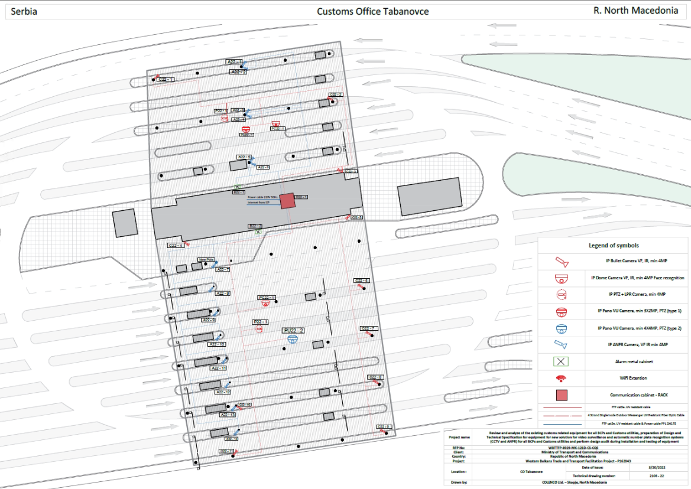

Drawings: 7_Co_Bogorodica

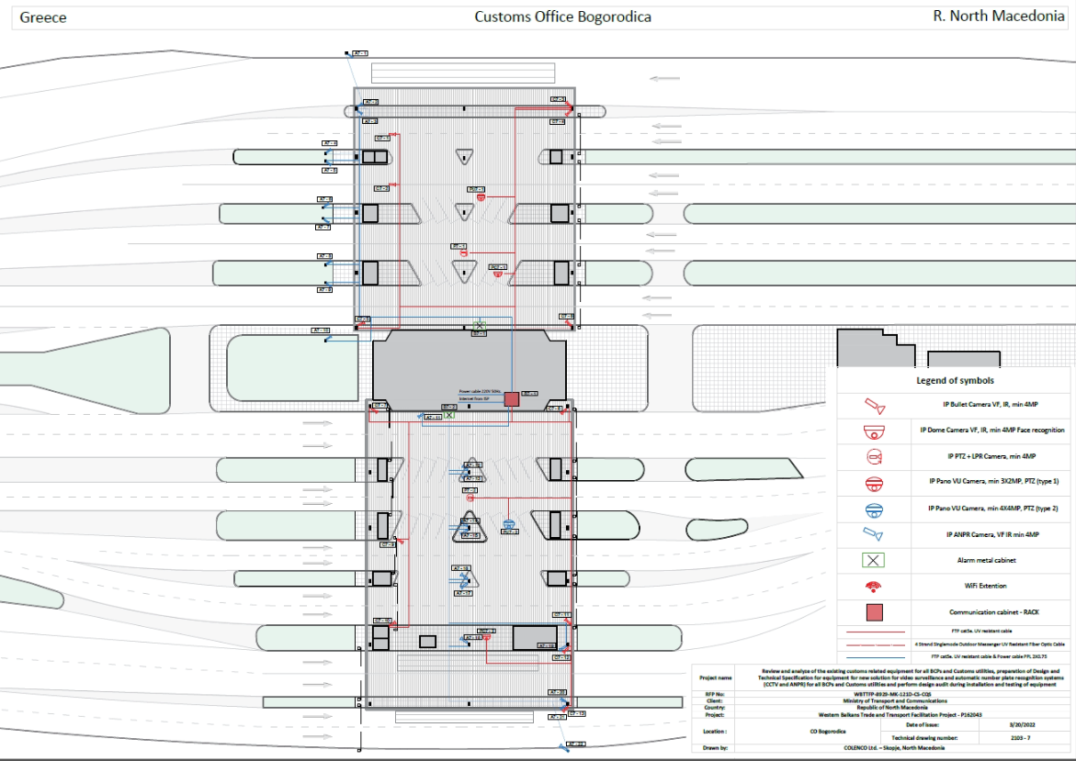

All other terms and conditions indicated in the RFB remain unchanged.

Please note that confirmation by e-mail of the receipt of this Clarification no.1 is compulsory!

Yours sincerely,

Slavko Micevski
Procurement officer

Western Balkans Trade and Transport Facilitation Project
Local Roads Connectivity Project
T: +38975494977
E: slavko.micevski.piu@mtc.gov.mk
Ministry of Transport and Communications
Crvena Skopska Opstina 4, 1000 Skopje
Republic of North Macedonia
www.mtc.gov.mk

